Ocean Lu  
CS 3010  
Professor   
11/04/19

Programming Project 2

Please view the link for source code: <https://colab.research.google.com/drive/1LFAN_636FjU95JrHzYgltZuvYlvwxWcO>

**Bisection Method**

My code for this method looks like:

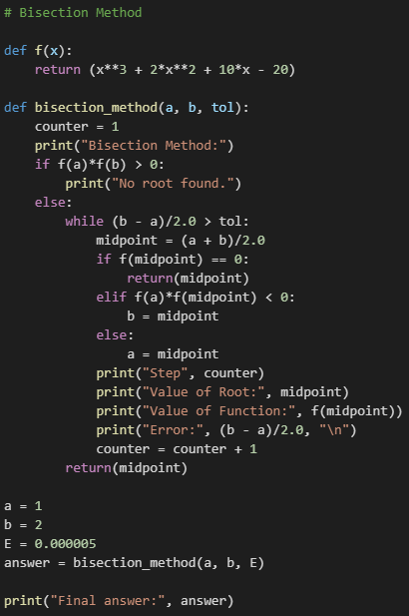

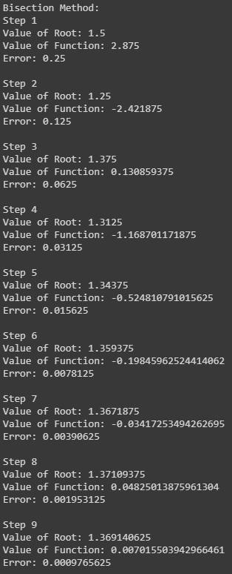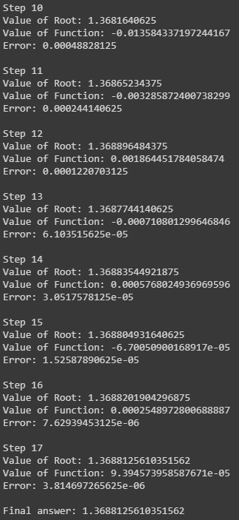The output looks like:

Table of the results for Bisection method:

|  |  |  |  |  |
| --- | --- | --- | --- | --- |
| n | Value of Root | Value of Function | Error | % Error |
| 1 | 1.5 | 2.875 | 0.25 | 25 |
| 2 | 1.25 | -2.421875 | 0.125 | 12.5 |
| 3 | 1.375 | 0.130859375 | 0.0625 | 6.25 |
| 4 | 1.3125 | -1.168701171875 | 0.03125 | 3.125 |
| 5 | 1.34375 | -0.524810791015625 | 0.015625 | 1.5625 |
| 6 | 1.359375 | -0.19845962524414062 | 0.0078125 | 0.78125 |
| 7 | 1.3671875 | -0.03417253494262695 | 0.00390625 | 0.390625 |
| 8 | 1.37109375 | 0.04825013875961304 | 0.001953125 | 0.1953125 |
| 9 | 1.369140625 | 0.007015503942966461 | 0.0009765625 | 0.09765625 |
| 10 | 1.3681640625 | -0.013584337197244167 | 0.00048828125 | 0.048828125 |
| 11 | 1.36865234375 | -0.003285872400738299 | 0.000244140625 | 0.024414063 |
| 12 | 1.368896484375 | 0.001864451784058474 | 0.0001220703125 | 0.012207031 |
| 13 | 1.3687744140625 | -0.000710801299646846 | 6.103515625e-05 | 0.006103516 |
| 14 | 1.36883544921875 | 0.0005768024936969596 | 3.0517578125e-05 | 0.003051758 |
| 15 | 1.368804931640625 | -6.70050900168917e-05 | 1.52587890625e-05 | 0.001525879 |
| 16 | 1.3688201904296875 | 0.0002548972800688887 | 7.62939453125e-06 | 0.000762939 |
| 17 | 1.3688125610351562 | 9.394573958587671e-05 | 3.814697265625e-06 | 0.00038147 |

Plot:

**False Position Method**

My code for this method looks like:

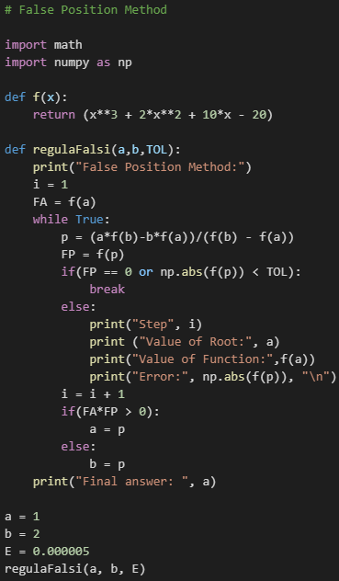

The output looks like:

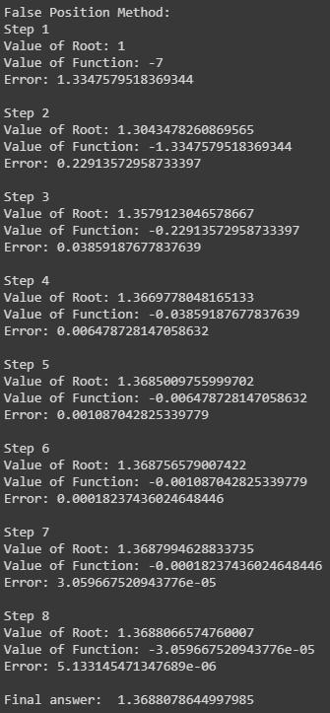

Table of the results for False Position Method:

|  |  |  |  |  |
| --- | --- | --- | --- | --- |
| n | Value of Root | Value of Function | Error | % Error |
| 1 | 1 | -7 | 1.3347579518369344 | 133.4757952 |
| 2 | 1.3043478260869565 | -1.3347579518369344 | 0.22913572958733397 | 22.91357296 |
| 3 | 1.3579123046578667 | -0.22913572958733397 | 0.03859187677837639 | 3.859187678 |
| 4 | 1.3669778048165133 | -0.03859187677837639 | 0.006478728147058632 | 0.647872815 |
| 5 | 1.3685009755999702 | -0.006478728147058632 | 0.001087042825339779 | 0.108704283 |
| 6 | 1.368756579007422 | -0.001087042825339779 | 0.00018237436024648446 | 0.018237436 |
| 7 | 1.3687994628833735 | -0.00018237436024648446 | 3.059667520943776e-05 | 0.003059668 |
| 8 | 1.3688066574760007 | -3.059667520943776e-05 | 5.133145471347689e-06 | 0.000513315 |

Plot:

**Newton Method**

My code for this method looks like:

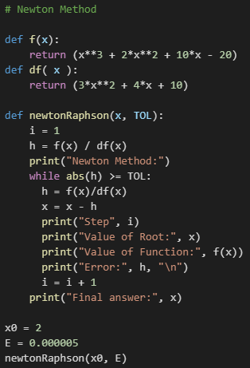

The output looks like:

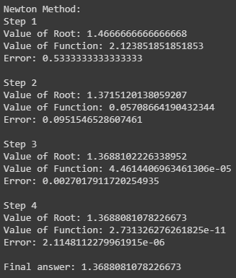

Table of the results for Newton Method:

|  |  |  |  |  |
| --- | --- | --- | --- | --- |
| n | Value of Root | Value of Function | Error | % Error |
| 1 | 1.4666666666666668 | 2.123851851851853 | 0.5333333333333333 | 53.33333333 |
| 2 | 1.3715120138059207 | 0.05708664190432344 | 0.0951546528607461 | 9.515465286 |
| 3 | 1.3688102226338952 | 4.4614406963461306e-05 | 0.0027017911720254935 | 0.270179117 |
| 4 | 1.3688081078226673 | 2.731326276261825e-11 | 2.1148112279961915e-06 | 0.000211481 |

Plot:

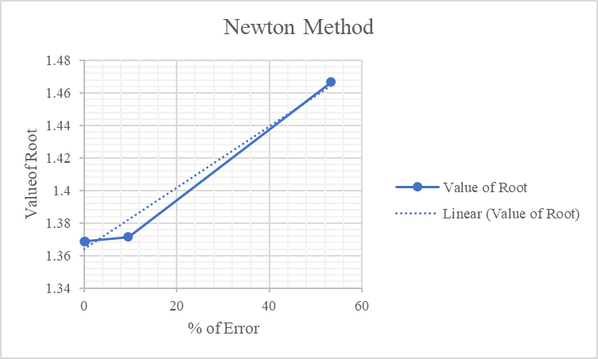

**Secant Method**

My code for this method looks like:

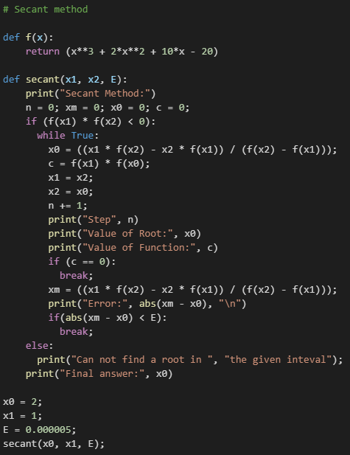

The output looks like:

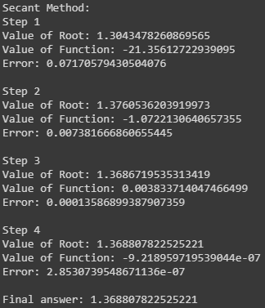

Table of the results for Secant Method:

|  |  |  |  |  |
| --- | --- | --- | --- | --- |
| n | Value of Root | Value of Function | Error | % Error |
| 1 | 1.3043478260869565 | -21.35612722939095 | 0.07170579430504076 | 7.170579431 |
| 2 | 1.3760536203919973 | -1.0722130640657355 | 0.007381666860655445 | 0.738166686 |
| 3 | 1.3686719535313419 | 0.003833714047466499 | 0.00013586899387907359 | 0.013586899 |
| 4 | 1.368807822525221 | -9.218959719539044e-07 | 2.8530739548671136e-07 | 2.85307E-05 |

Plot: